Software Requirements Specification for ABC Asset Management Fund Fact Sheet Generator

|  |  |
| --- | --- |
| **Project ID** |  |
| **Project Name** | ABC Asset Management Fund Fact Sheet Generator |
| **Account** |  |
| **Business Unit / Global Account** |  |
| **Project Manager** |  |
| **Document Version Number** | 1.0.0 |
| **Approved by** |  |

# Revision History

|  |  |  |  |  |  |
| --- | --- | --- | --- | --- | --- |
| **Version Number** | **Release Date** | **Description of Change/s made** | **Author**  **(Name & Role)** | **Reviewer**  **(Name & Role)** | **Approver**  **(Name & Role)** |
|  | Mmm-DD-YY |  |  |  |  |
|  |  |  |  |  |  |
|  |  |  |  |  |  |

Table of Contents

Revision History 2

1.0. Introduction 4

1.1 Scope of the Project 4

1.2 Objective of this Document 4

1.3 Acronyms, Abbreviations, and Definitions Used 4

1.4 Related Documents 4

2.0 Overall Description of the Project 5

3.0 Project Execution Requirements 5

3.1 Deliverables and Delivery Dates 5

3.2 Technical Environment to Be Used 5

3.3 Testing Strategy 5

3.4 Acceptance Criteria 5

3.5 Perceived Risks and Contingencies 5

4.0 Specific Requirements 6

4.1 Functionality Requirements 7

4.2 End-User 8

4.3 Reliability Requirements 8

4.3.1 Data accuracy 8

4.3.2 Error handling 8

4.4 Performance Requirements 8

4.4.1. Time taken to generate fund sheet 8

4.4.2 Retrieval of past records 8

4.5. Supportability Requirements 8

4.5.1. Maintenance access 8

4.6. Design Constraints 8

4.7. User Documentation and Help System Requirements 9

4.8. Purchased Components 9

4.9. Interfaces 9

4.9.1. User Interfaces 9

4.9.2. Hardware Interfaces 9

4.9.3 Software Interfaces 9

4.9.4. Communications Interfaces 9

5.0 Supporting Information 10

# 1.0. Introduction

ABC Asset Management (ABC) is one of Singapore’s oldest investment companies, created in 1968. ABC manages $20 Billion of assets, making it the largest active manager in Singapore. As a leading global asset manager, ABC is dedicated to creating long-term value for their clients. The investment needs of their clients are at the heart of what they do. ABC’s customers now need a daily Fund Fact sheet in the format attached.

## 1.1 Scope of the Project

ABC daily fund fact sheet generator will generate a daily fund fact sheet and will email to clients and company. The fund details and fund manager details are configurable. It will generate fact sheets for both Prestige and Global market. It will display performance overview, sector allocation top five holdings and fund details.

## 1.2 Objective of this Document

This SRS (Software Requirement Specification) serves as a contract between the development team and ABC Asset Management (ABC). The SRS highlights the requirements for the daily fund fact sheet generator detailing the functional and non-functional aspects. This SRS provides an easy generator system as required by the client.

## 1.3 Acronyms, Abbreviations, and Definitions Used

* SGX - Singapore Exchange Limited
* NYSE - New York Stock Exchange
* Bid-Bid – Growth of bid value from stated time to current time
* Offer-Bid – Current offer value to bid value of stated time
* Benchmarks – unmanaged group of securities which are used to measure a fund's/stock's performance
* NAV - The net asset value (NAV) represents the net value of an entity and is calculated as the total value of the entity’s assets minus the total value of its liabilities

## 1.4 Related Documents

<https://sg.finance.yahoo.com/>

<https://www.nyse.com/index>

<https://www2.sgx.com/>

# 2.0 Overall Description of the Project

ABC daily fund fact sheet generator will generate a daily fund fact sheet when the market closes and will email a copy to clients and company. The robot can be configured using a companion application to change the fund details and fund manager details. It will generate fact sheets for both Prestige and Global market. It will display performance overview i.e Bid-Bid, Offer-Bid and benchmarks against the designated markets i.e SGX and NYSC. It will display the performance overview and sector allocation of the fund in a graph format. It will display the top five holding that the mutual fund invests in. It displays the fund details in a table format.

# Project Execution Requirements

## 3.1 Deliverables and Delivery Dates

Deliverables will be a windows app that will be used by the fund manager to change and configure the fact sheet details with the dead line set 1 month after starting the project

## 3.2 Technical Environment to Be Used

Software that is required for the project will be Uipath studio, Uipath robot, Microsoft excel, mysql, visual studio 2017 all running on windows 7 and above platform. The uipath robot, excel and sql server will be installed on the client’s computer while visual studio and

## 3.3 Testing Strategy

The resulting pdf will be compared with the previous month pdf to test if the generation is done correctly with the same formatting

## 3.4 Acceptance Criteria

* Fact sheet generated in the correct format
* Fact sheet is generated within 10mins
* Fact sheet is generated automatically at fixed timing each day
* Information on the fact sheet matches the user’s own data
* Windows application allows user to see past fact sheet based on the date selected

## 3.5 Perceived Risks and Contingencies

Websites that the robot use for scraping data will always be available during the generation and the data accurate and up to date. Fund manager has basic knowledge of using computers. The robot will be running on windows platform. User has their own mailing list for subscriber for testing purposes we will use an excel to simulate the mailing list. The user has basic knowledge of UiPath orchestrator.

## 4.0 Specific Requirements

## 4.1 Functionality Requirements

Login console

Access console

Success

Access orchestrator

Logout console

ABC Fund Manager

Update fund details

Investors

Generate fact sheet

login orchestrator

View fact sheet

Search fact sheet

Logout orchestrator

Update schedule

Send email

Success

Add fund

Remove fund

|  |  |
| --- | --- |
| **USE CASE** | **DESCRIPTION** |
| Login console | Client must have login before starting any activity in Console |
| Access console | Client may access his account after login. |
| Search fact sheet | Client shall be able to search for a particular fact sheet with details. |
| View fact sheet | Client shall be able to view a particular fact sheet with details. |
| Add fund | Client shall be able to add new fund. |
| Remove | Client shall be able to remove fund. |
| Login orchestrator | Client must have login before starting any activity in Orchestrator. |
| Access orchestrator | Client may access his account after login. |
| Update schedule | Client may update the schedule. (i.e. can make modification as their wish.) |
| Logout orchestrator | Client safely logout after finish updating. |
| Logout console | Client safely logout after finish using the console. |
| Update Excel configuration file | Client may update any information of the fund. |
| Generate fact sheet | System shall generate fact sheet. |
| Send email | System shall send out email with fact sheet attached. |

### 4.1.1 Web crawling

Access yahoo finance and scrape the respective stock price off the webpage

Access SGX and NYSE and get benchmark value

Store scrape data to database

### 4.1.2 Configure fund details

Log into windows application to configure fund details

### 4.1.3 Generate required details for each fund

### 4.1.3.1 NAV calculation

Calculation of NAV bid and bid offer

### 4.1.3.2 Performance overview graph

Plot the graph for performance overview

### 4.1.3.3 Performance history graph

Generate table for performance history

The table will be in the following format:

|  |  |  |  |  |  |
| --- | --- | --- | --- | --- | --- |
| Month to date | 1 day | 3 day | 1 week | 1 month(30 days) | Day since inception |

### 4.1.3.4 Portfolio analysis graph

Plot the graph for portfolio analysis

### 4.1.3.5 Sector allocation diagram

Plot diagram for sector allocation

### 4.1.3.6 Top five holdings comparison chart

Generate chart for top five holdings

### 4.1.3.7 Fund Detail table

Generate table for Fund Detail

### 4.1.3.8 Generate PDF

### 4.1.4 Send generated PDF to subscribers

## 4.2 End-User

User shall be trained to configure the robot using the orchestrator functions in one working day. A simple windows application will be used for configuration and checking previous data. User will have knowledge of stock codes to configure the robot.

## 4.3 Reliability Requirements

### 4.3.1 Data accuracy

The robot shall have an accuracy of at least 99% on the fact sheet and will be able to recover from errors by itself in 2mins.

### 4.3.2 Error handling

The robot shall recover from a runtime error after failing to generate fact sheet or encounter a run time error in 10mins and shall send an alert to the administrator’s attention

## 4.4 Performance Requirements

### 4.4.1. Time taken to generate fund sheet

The robot shall take approximately 10 mins to generate the fact sheets for each market.

### 4.4.2 Retrieval of past records

The windows app should be able to retrieve information in approximately 5 mins when the user selected the date for viewing past fund sheet records

## 4.5. Supportability Requirements

This section indicates any requirements that will enhance the supportability or maintainability of the system being built, including coding standards, naming conventions, class libraries, maintenance access, maintenance utilities.

Under each one of the following subsections (change the title of the sub-sections), describe the corresponding supportability requirement.

### 4.5.1. Maintenance access

Only the fund manager will be able to log into the system to edit the fund details. The fund manager will also have access to the orchestrator to configure the time the robot will run its process

## 4.6. Design Constraints

* The system shall be developed using RPA tool, UiPath.
* The computer must be equipped with web browsers such as Google Chrome.
* The computer must have Microsoft Excel application installed.
* The windows application used by the fund manager should be user friendly.
* The user must have a UiPath Orchestrator account.

## 4.7. User Documentation and Help System Requirements

A user manual will be available to the fund manager with clear instructions and screenshots on how to use the application and configure the orchestrator online. Issues with orchestrator will be directed to Uipath orchestrator help desk

## 4.8. Purchased Components

Purchased components will be license for Uipath orchestrator and office excel

## 4.9. Interfaces

### 4.9.1. User Interfaces

The windows application will be simple and consistent, using terminology commonly understood by the intended users of the system to eliminate the need for user training of infrequent users. User testing will be used to ensure the user interface is clear (simple, commonly understood vocabulary, intuitive to use without training), complete and consistent.

### 4.9.2. Hardware Interfaces

No extra hardware interfaces are needed. The system will use the standard hardware and data communications resources provided by the Client. This includes, the general Ethernet network connection at the hosting site. This system requires a minimum spec for the PC running the robot is as stated:

•CPU. 1.4GHz 32-bit (x86) Dual Core 1.8GHz 64-bit

•RAM. 4 GB or more etc.

### 4.9.3 Software Interfaces

The system will use the standard software resources provided by the client.

Operating system: Windows 7 and above

.NET Framework: minimum: 4.6.1

Other Software: Excel 2000 and above, Adobe PDF, Chrome.

### 4.9.4. Communications Interfaces

The system will use the communications resources provided by the Client. This includes, but is not limited to, HTTP protocol for communication with the web browser and the web server and TCP/IP network protocol with HTTP protocol.

## 5.0 Supporting Information

### 5.0.1 Mailing list

Client will either need to provide a mailing list or a master mail that will forward our mail to their clients. If a mailing list is provided, it is expected to be in the form of an excel sheet, where the mails are populated through the first column. The client is also expected to provide us with any necessary information such as the customer name if they want us to send a customized email. The updating of email addresses and any relevant details is expected to be done by the client.

### 5.0.2 Fund details

Client will need to provide us with all the details stated in the fund detail column of the fact sheet. The updating of fund details can be done via a separate app that will log into the databases to used to change the constants.

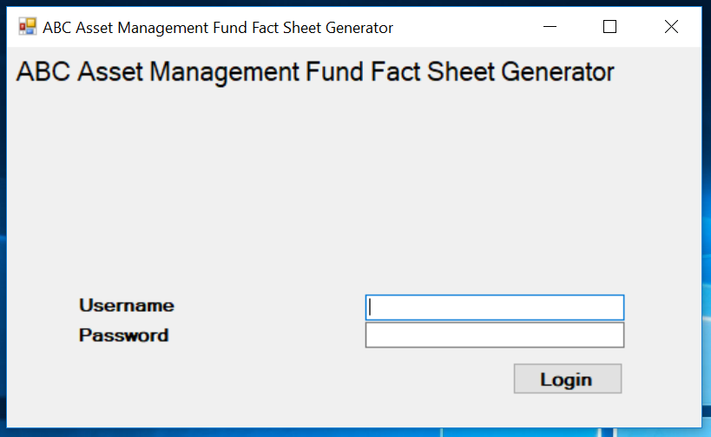

### 5.0.2 Fund fact sheet

System shall generate the fund fact sheet as illustrated below:

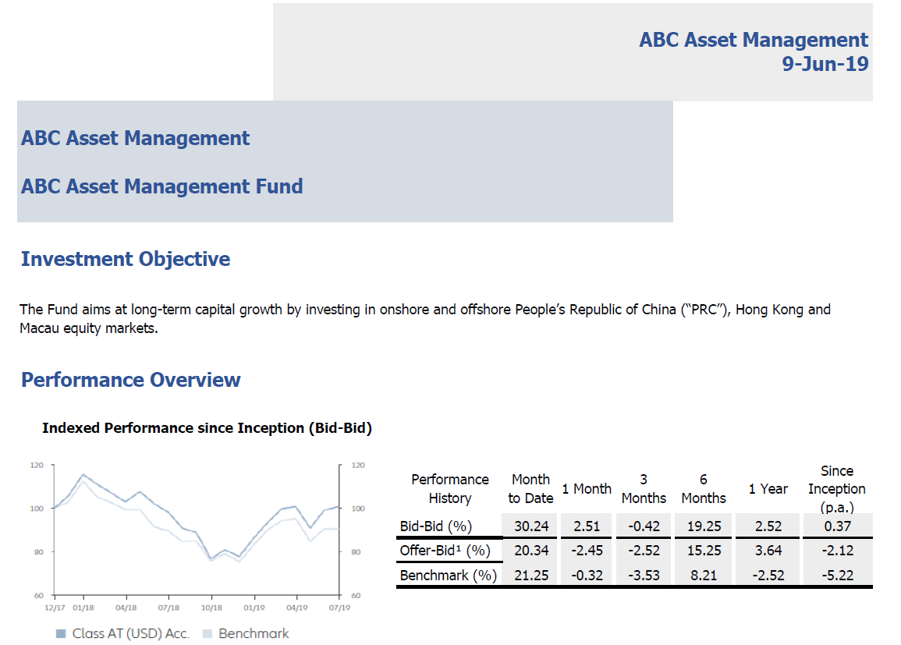

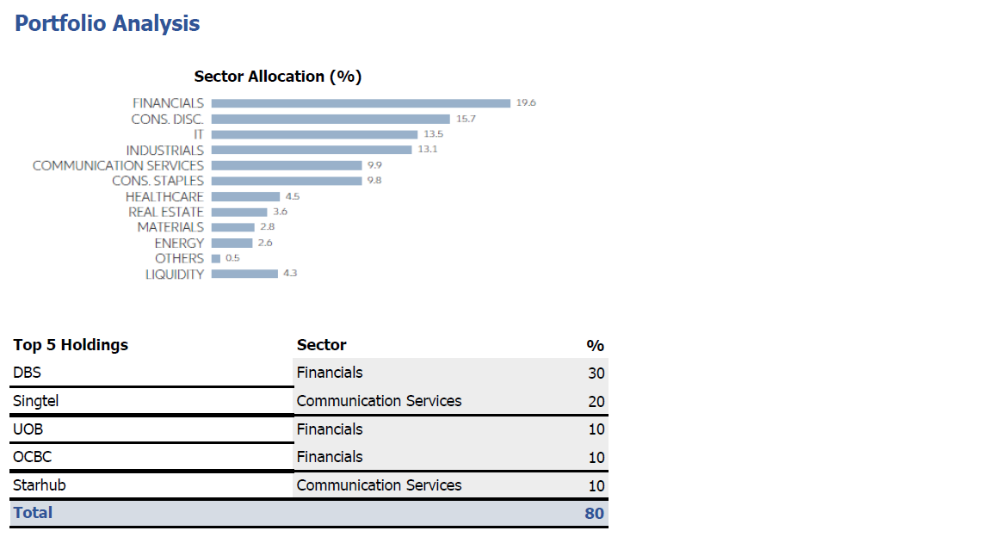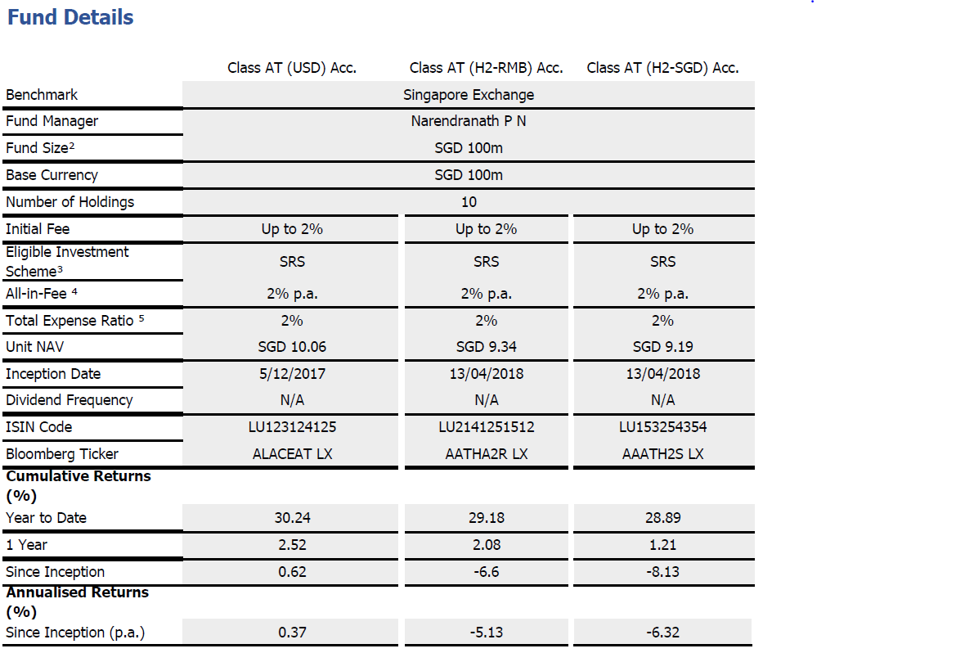

**Template Revision History (For EPEX Use Only)**

|  |  |  |  |  |  |  |
| --- | --- | --- | --- | --- | --- | --- |
| **Version Number** | **Release Date** | **Description of Change/s made** | **Author**  **(Name & Role)** | **Reviewer**  **(Name & Role)** | **Approver**  **(Name & Role)** | **QMS Release Version** |
| 1.0 | NA | Initial baseline | NA | NA | SEPG | NA |
| 2.0 | Jun-14-11 | Assigned artifact id, version #, release date to the template and modified Information Classification label in the footer | Shreevidhya Srinivasan, PM | Radhika Seenivasakan, SEPG | Rajesh Sreekumar, SEPG | 4.2 |
| 2.1 | Nov-30-18 | As a part of Re-Org, updated references to CQ and SEPG as EPEX | Prakash Palaniswamy | Pradeep Kumar Pullathil | Pradeep Kumar Pullathil | 7.5 |